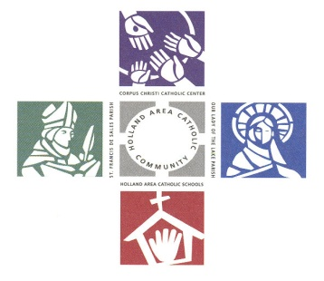 **Corpus Christi Foundation**

**Guidelines – 2026 Grants**

Thank you for your interest in applying for funding from the endowment earnings of the Corpus Christi Foundation. The mission of the Corpus Christi Foundation is to work toward providing a financial base that supports the religious, educational, ministerial, and charitable needs of **Corpus Christi Catholic School and Center**, **Our Lady of the Lake and St. Francis de Sales Parishes**. In keeping with the Gospel message, the foundation strives to build financial security for future generations by maintaining permanent endowment funds and encouraging stewardship of current and future planned gifts.

**Listed are guidelines that must be followed when applying for funds:**

- Projects that are innovative, collaborative, and/ or integrate our Catholic community are encouraged.

- Projects that relieve financial deficits, fund general administrative costs, or grants made to individuals **will not be considered**.

- Projects should have clear and measurable results or outcomes.

- There is no minimum amount for which you may apply.

- The Foundation’s goal is not to be the single source of funding for all projects. We endeavor to distribute funds to all entities. We suggest a funding cap of $1,500 per project, but would consider funding larger projects, especially those that integrate our Catholic community.

- If you submit multiple applications**,** please rank them in order of importance on each application by indicating if this is your first, second, or third choice.

- If the total cost of your project were to exceed the funded amount, please identify your other source of funds.

- Following are additional items considered when applications are reviewed:

* + The project has direct impact on evangelizing the Catholic faith or improving academic success
  + The project has lasting impact
  + The number of people the project impacts

**Process:**

Grant application forms are available at the parishes, school, and on the CCF website. If you have any questions, please contact Karen Brown ([kgbrown22@yahoo.com](mailto:kgbrown22@yahoo.com)) prior to the due date.

- To be considered, **applications must be submitted by 5:00 PM on Friday, December 5, 2025.**

* **Each application requires** **two signatures**, **the applicant’s and the pastor’s** **or principal’s**. **However, if the application is a joint project (e.g., between two parishes, or parish(es) and school), the application must be signed by the applicant and by both pastors or by pastor(s)/principal, as applicable.**

- All applicants will be notified by February 6, 2026 of the decision regarding their application.

- Checks for awarded grants will be mailed to your pastor or principal, earmarked for your grant.

Finally, we ask that you report the results of your project by completing a CCF Grant Evaluation Formwhen requested. **As a part of the CCF Grant Evaluation Form, please note that receipts will need to be submitted for items purchased with grant funds.**

**The Distribution Committee of the Corpus Christi Foundation**